Program Sustainability Plan

How do you turn business metrics into “actionable data”? This template provides a way to show the meaning of the metrics, how the organization is doing against best practices, and what possible actions can help improve performance

Performance Metric | Organizational Performance | Best Practice/Target | Action Steps
Administrative Overhead:  What percentage of the personnel budget is spent on:  Administrative staff – those who deal with operations/finance  Support staff – coaches, cooks, etc.  Direct teaching staff – staff working in classrooms and counted in ratios  Rationale: The goal is to deploy the highest possible level of resources into classroom staff in order to attract and retain a well-qualified workforce  GOAL: Administrative Overhead not more than 20% | 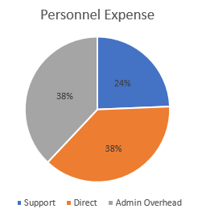 | Administrative – 20%  Support staff --- 20%  Direct teaching staff – 60% | --Review Operations process and practices to ensure the program is operating efficiently (benefitting from automation when possible)  --Review Organizational Chart/Job Descriptions to identify opportunities to streamline and reduce the number of non-program staff  --Design and implement compensation initiative for direct staff that does the following:  --ensures internal and external parity with comparable positions  --creates opportunities for teachers to have “time off the floor” for planning and reflective practice

Enrollment by Classroom and Site:  This metric measures how fully enrolled each classroom is as a percentage of “staffed capacity”  Rationale: Programs must remain fully enrolled in order to be financially viable – empty seats = lost revenue  Goal: No classroom below 90% enrollment | 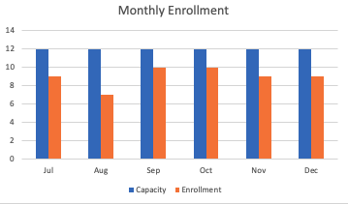 | --Average enrollment rate of 90%  --Time to fill slot >10 days | --Marketing effort (describe work to be done)  --“bonus for finding a family that enrolls”  --Create a Facebook page for the program for advertising, etc.…  --Reassigning classrooms and consolidating so that classrooms are full  --mixed aged groupings, etc.…
Collection Rate/Bad Debt:
How much of revenue owed is actually received by the organization? How much revenue is collected on time? How much is written off as “non-collectable”?

Rationale: Many providers find it difficult to collect funds from families facing hardships and/or being fully reimbursed for cc subsidy services

Goal: 100% Collection Rate
Cost per Child/Revenue Gap:
Understanding the true cost of care by age group/site; comparing the cost with the actual operating revenue that is secured by the program

Rationale: A sign of fiscal health is when a program is able to identify operating revenue to meet (or come close) to the actual cost of care; too heavy reliance on philanthropic fundraising will undermine a program’s sustainability because it relies too heavily on successful fundraising work rather than fee for service

Goal: At least 80% of the cost of care is raised through sustainable core operating funds

